


This product is an innovative approach to delivering ice, new, revolutionary, and one of a kind.
using patented technology an Ice House manufactures its own ice, bags it, and drops it out like
a can of coke. In addition, our ice is never touched by human hands, possibly making it the
cleanest, safest ice on the market today. These cool vending machines will forever change
the way ice is sold, saving the consumers both time and money.
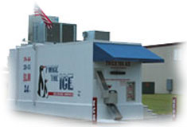
www.texasiceexpress.com

Everyone is familiar with the present system of purchasing ice at grocery or convenience stores.

You've probably experienced it yourself: standing in line to pay, collecting your bag (if you

remember), and at some point banging the ice on a hard surface to break it into useable pieces

and sometimes breaking the bag, “Twice the Frustration”. With an Ice House, ice is produced

and delivered to consumers using a unique vending strategy equivalent to the drive up

convenience of an ATM machine. A 16 pound bag of ice is bagged and dispensed in 8 seconds

or 20 pounds of loose ice is dropped directly into the consumers cooler. The ice is chipped,

deliciously chewable, and is never frozen together. It is available 24 hours a day, 7 days a
week. In most areas it is priced at about 1/2 the price of other ice products. Amazingly the
ice never touches human hands.

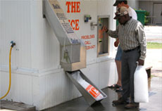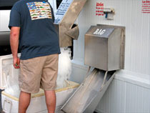

- Purchase an ice house or exclusive development area
- Lease a small plot of land or commercial parking lot
- Setup your utilities - water, phone, and electricity.
- Practically no supplies, only plastic bags and twist ties
- A crew will deliver and install the machine
- Have fun at your grand opening and ribbon cutting ceremony
- Enjoy the recurring income

We believe our ice is the cleanest, safest ice on the market today. Ice World Journal reports

that according to the CDC "Hand-based contamination is one of the leading sources for

passing illness...". Our ice is never touched by human hands. All material that comes in

contact with our ice during production is made of 100% food grade stainless steel.

Once produced the ice is stored in a self contained food grade stainless steel bin. After

the customer deposits his/her money, ice is mechanically dropped into a bag or loose ice chute

and is delivered to the consumer automatically.

Ice House Protected Trade Area Sample

No other buyer will be allowed to place and Ice House within the radius of a Protected Trade
Area. Each radius is determined by population and traffic count.

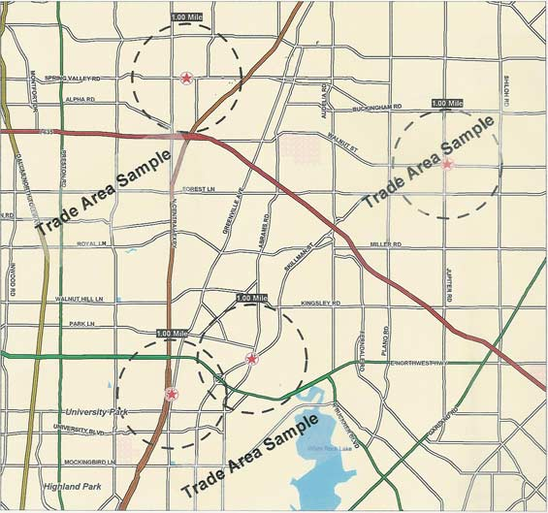

Bank Presentation Instructions

A Bank Presentation can be created using the distributor documents in User Level I of our website. Please consult with your Dealer or Sub Dealer for recommendations using your presentation.

Pages 1-3
Investor/Bank Presentation

Pages 4-5
Monthly Graphs with Bags per Day of Existing Ice Houses

Page 6
Daily Performance Chart of Existing Ice House

Pages 7-12
Select one model of the 12 Year Projections of 100-250 Bags per Day. Use the plug page on the model you select to customize your projections.

    - Bind with all documents with a clear front cover and solid back cover to create a professional looking bank presentation.

    - A Business Plan to accompany your Bank Presentation is also available through Texas Ice Express.

    - For more information encourage your banker visit the website.

    - One loan option is a low document SBA Short Form application; many SBA preferred banks will fund 80% of the entire investment within 14 days. In some areas Texas Ice Express has preferred SBA lenders available.

    - Recommendations to increase start up cash flow:
- Request 7-10 year financing.
- Depending on the time of year request 3-6 months of interest only payments.

